1. 
2. In the previous lecture, we mapped the exception to a response. So you can now control what is status code what is the JSON response in case of exception.
3. There are exceptions which JAX-RS doesn’t know what to do with them so you map exceptions to some JSON response what there are exceptions which are known to JAX-RS has its own set of exceptions about which it knows and accordingly, it maps to some status and a response. So, for those exceptions, you don’t need to write Exception Mappers for those exceptions.
4. 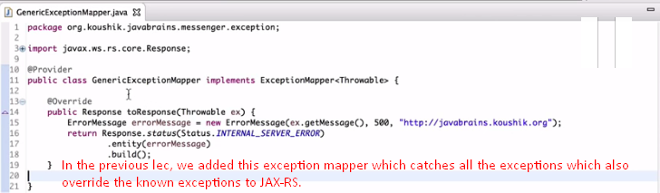
5. Let’s delete this mapper.  
     
   Web ApplicationException: The exception which is known to JAX-RS API already and you don’t need to write exception Mapper. 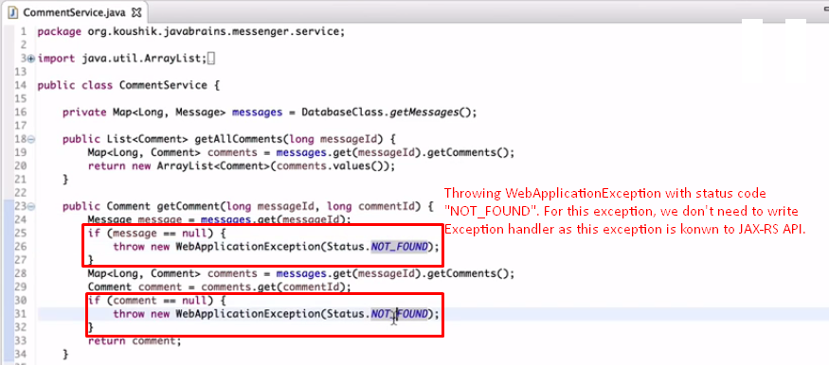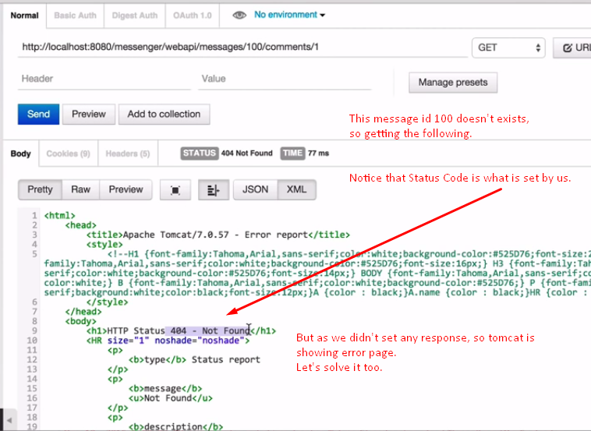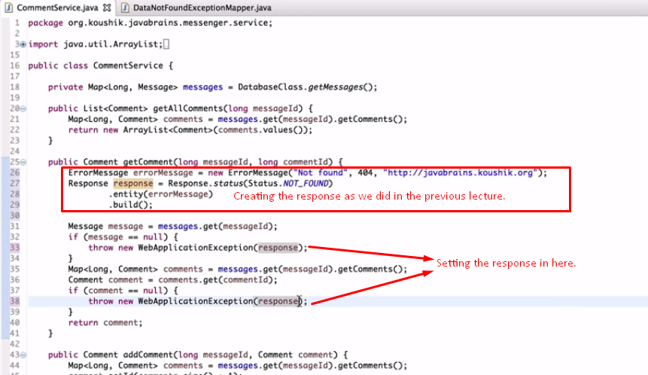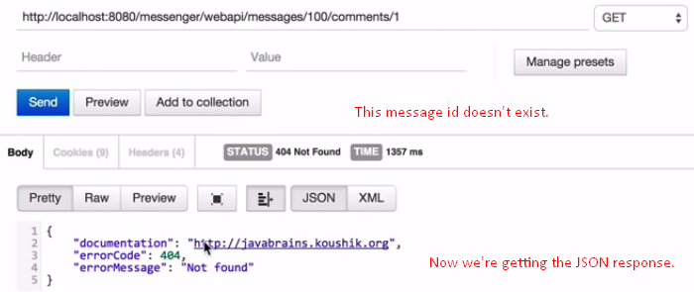
6. There are subtypes of WebApplicationException which provide custom responses and status. 